|  |  |  |
| --- | --- | --- |
| 浙江大学信息与电子工程学院 | **集成电路原理与设计** | 2023年10月 |
| 2023-2024学年春夏学期 |



**Exercise 1**

1. Two layouts of n-channel MOSFET are shown in Fig.1.1. What is the width and length of the two devices?

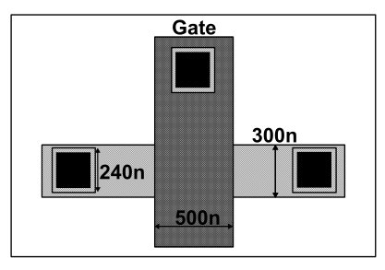 

1. (b)

Fig.1.1

***Answer:***

1. Length=500n; Width=300n
2. Length= $5×25μm=125μm$; Width= $4μm$
3. The layouts of a circuit are shown in Fig.1.2. Give the corresponding schematics and its function, and mark the *W*/*L* sizes of each transistor. Assume *L*=2*λ*，*λ*=0.4μm.

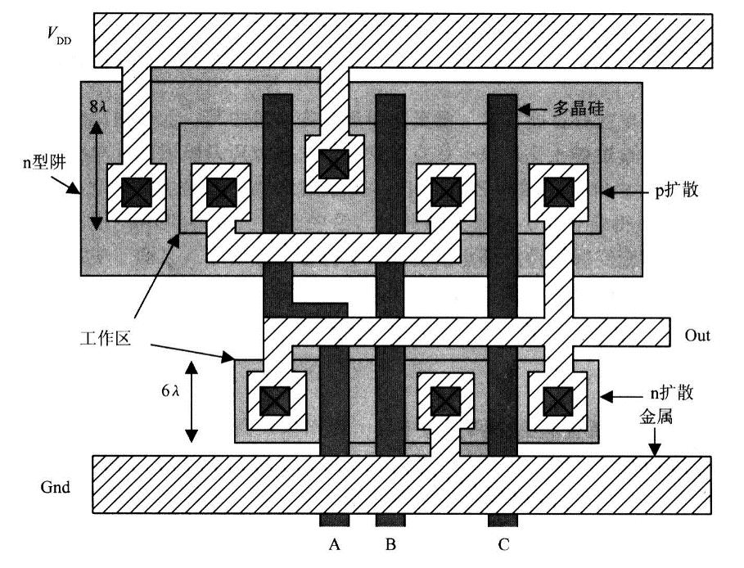

1. **p-sub, n-well technology**



**(b) dual-well technology, and $clk^{'}=\overline{clk}$**

Fig.1.2

***Answer:***

(a)



Out=

W/L of N-MOSFET: 

W/L of P-MOSFET: 

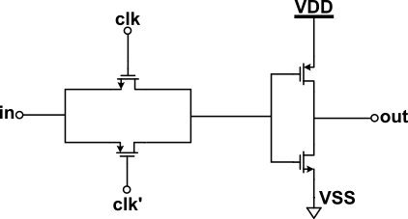

CLK high: Out= $\overline{IN}$

CLK low: Out=0

W/L of N-MOSFET:

$$\frac{λ}{2λ}=\frac{0.4}{2×0.4}=\frac{0.4}{0.8}$$

W/L of P-MOSFET:

$$\frac{λ}{2λ}=\frac{0.4}{2×0.4}=\frac{0.4}{0.8}$$

1. Layout of a different pair with PMOS current source loads in p-sub N-well technology is shown as Fig.1.3. Give the corresponding schematics and mark the W/L sizes of each transistor. Assume λ=0.4μm.

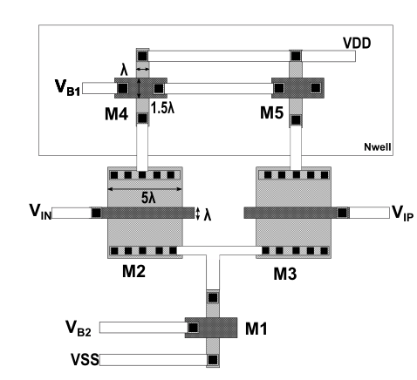

Fig.1.3

***Answer:***

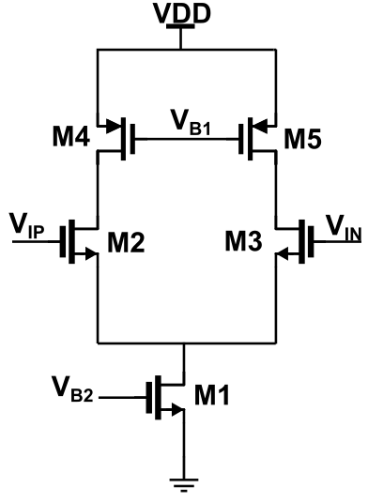

**M1=M4=M5 $\frac{W}{L}=\frac{λ}{1.5λ}$**

**M2=M3 $\frac{W}{L}=\frac{5λ}{λ}$**